APW3++ Output Voltage

Modification Guide

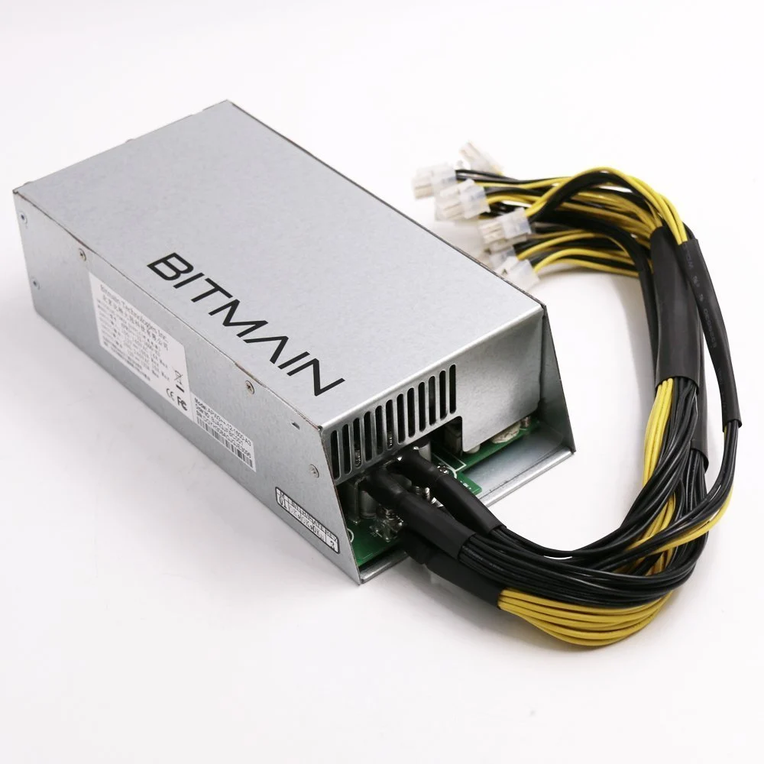

**Table of Contents**

# 

**Warnings and Disclaimers 2**

**Overview 3**

**12-12.5V DC Modification Instructions 4**

Recommended Tools for Modification 4

Modification Steps 4

Step 1 4

Step 2 5

Step 3 6

Step 4 6

Step 5 6

Step 6 6

Step 7 8

Step 8 8

Step 9 8

**Above 12.5V DC Modification Instructions 9**

Recommended Tools and Parts for Modification 9

Modification Steps 10

Step 1 10

Step 2 10

Step 3 10

Step 4 11

Step 5 11

Step 6 12

Step 7 12

Step 8 13

Step 9 14

Step 10 15

Step 11 15

Step 12 15

Step 13 15

Step 14 15

**Selecting Resistor Value 16**

# 

# Warnings and Disclaimers

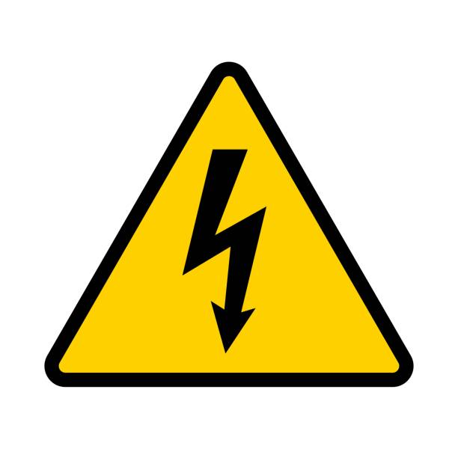

**WARNING: HIGH VOLTAGE!** HAZARD OF ELECTRICAL SHOCK: The power supply you are working on contains capacitors that store high levels of electrical energy that can be extremely dangerous or deadly **even when disconnected from the power source**. Extreme caution must be exercised when modifying the power supply. By adhering to the following safety precautions, you can minimize the risks associated with working on power supplies containing high voltage capacitors. Remember, safety should always be your top priority when dealing with electrical equipment.

1. Power Off and Disconnect: Prior to working on the power supply,

ensure that it is completely powered off and disconnected from the electrical outlet. Unplugging the power supply alone is not sufficient, as capacitors may still retain a dangerous charge. Double-check by verifying the absence of voltage with appropriate testing equipment.

1. Discharge Capacitors: Before attempting any repair or maintenance procedures, it is crucial to discharge the capacitors properly to eliminate stored electrical energy. Failing to discharge capacitors can result in electric shock. The APW3++ uses the cooling fan to discharge its high voltage capacitors. Ensure that the cooling fan continues to run for several seconds after unplugging the power supply and then stops. This indicates that the high voltage capacitors have been discharged.
2. Insulation and Protective Gear: When working with high voltage capacitors, it is imperative to wear appropriate personal protective equipment (PPE), such as insulating gloves, safety goggles, and non-conductive footwear. Insulation provides an additional layer of protection against electric shock and potential accidents.
3. One Hand Rule: Whenever possible, use the "One Hand Rule" while working with high voltage capacitors. This involves keeping one hand behind your back or in your pocket, ensuring that only one hand comes into contact with any part of the circuit. By doing so, the risk of current passing through your chest or vital organs is reduced in case of accidental contact.
4. Proceed with Caution: Even with proper precautions, high voltage capacitors can still pose risks. Exercise extreme caution and attentiveness during the entire repair process. Avoid unnecessary distractions and maintain a focused approach to ensure your safety and the integrity of the repair.



**WARNING:** Modifying the power supply’s output voltage will void its warranty. It is recommended to thoroughly research and evaluate the potential risks and benefits of modifying the power supply’s output voltage before proceeding.

# 

# Overview

The APW3++ Bitmain power supply has proven to be a useful PSU that offers a 1200 watt supply output at an output voltage of 12.15V DC from a standard 110V AC outlet. It was used to power several older generation cryptocurrency mining rigs like the Antiminer S9, the Antminer D3, and the Antminer L3. Due to the popularity of these mining rigs, millions of APW3++ units have been manufactured and are now available for relatively low prices on second hand markets or from 3rd party suppliers.

Now that the bitcoin mining industry has advanced several generations beyond the Antminer S9, the APW3++ is being used in various alternative use cases. For example, the APW3++ can be used to power new generation hash boards from 120V AC when paired with a Loki Kit from Pivotal Pleb Tech. Oftentimes these alternate use cases require output voltages above or below the nominal 12.15V DC stock voltage. This guide outlines 2 different methods for modifying the output voltage of the APW3++. The first and simplest method allows the voltage to be modified between 12.0 and 12.5V DC. See the “12-12.5V DC Modification Instructions” section below for more details. The second, more involved method allows the voltage to be modified between 12 and 14.1V DC. See the “Above 12.5V DC Modification Instructions” section below for more details.

# 

# 

# 

# 

# 

# 

# 12-12.5V DC Modification Instructions

The instructions in this section are for modifying the output voltage of the APW3++ to be between approximately 12 and 12.5V DC.

While this method is the easiest modification method, it doesn’t allow the voltage to be increased above 12.5V DC. If the end goal is to modify the output voltage above 12.5V DC, see the “Above 12.5V DC Modification Instructions” section below.

## Recommended Tools for Modification

The following tools are recommended for modifying the APW3++ output voltage to be between 12-12.5V DC.

|  |  |  |
| --- | --- | --- |
| #1 Phillips Screwdriver | ⅛” Flathead Screwdriver | Digital Multi Meter |

## 

## Modification Steps

### **Step 1**

Unplug the power supply from the wall and ensure that the PSU fan stays on momentarily (5 to 45 seconds) after the PSU is unplugged and then turns off. The power supply discharges its high voltage capacitors through the PSU fan to help reduce the risk of electrical shock. WARNING: if the PSU fan has been removed or disconnected from the PSU, the capacitors will likely remain charged and present an elevated risk of electrical shock. Please read and adhere to all safety precautions given on page 1 of this document.

### 

### **Step 2**

With the PSU unplugged and the PSU fan no longer running, remove the top PSU cover plate by removing the 6 side screws (circled in red below) with a phillips screwdriver and pulling up on the top cover plate.

### 

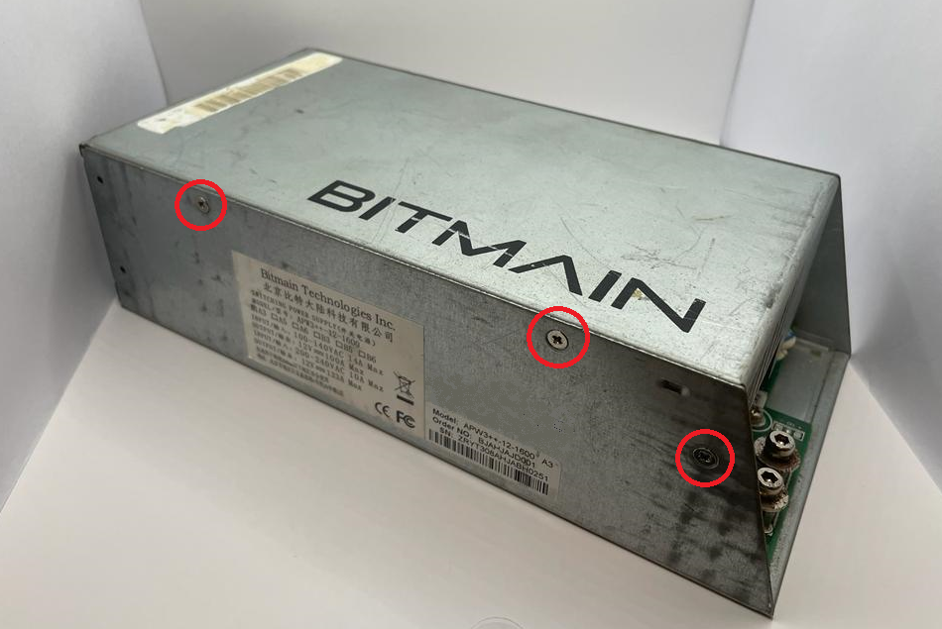

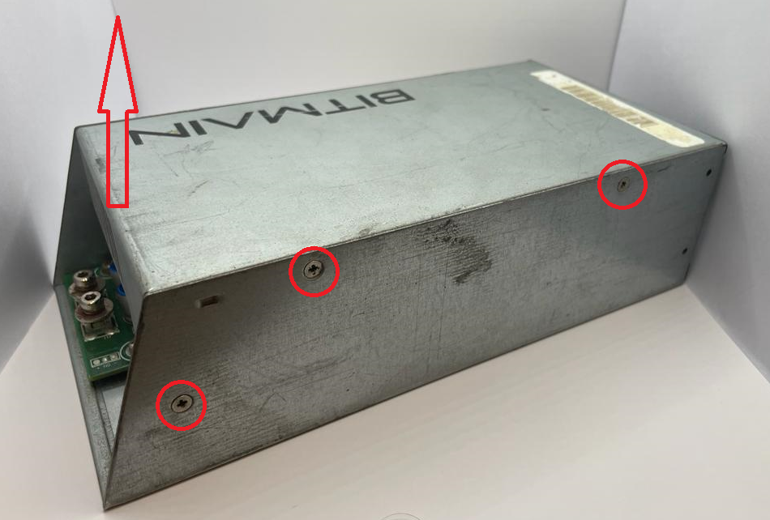

### 

### **Step 3**

Make note of the orientation of the top transparent plastic insulating shield. Remove it by lifting up on its edge. Set aside.

### 

### **Step 4**

Locate the potentiometer next to the large transformer. The potentiometer is a small blue box with a gold flathead screw.

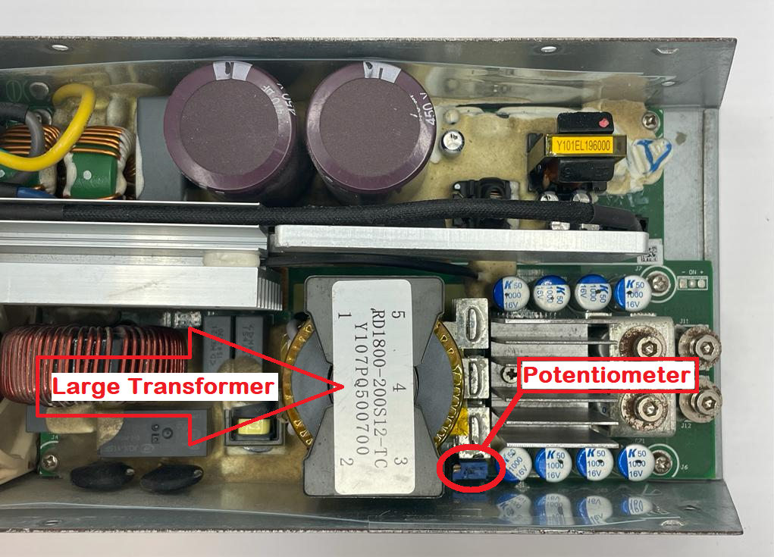

### 

### **Step 5**

Remove any epoxy that may be around the potentiometer screw head.

### **Step 6**

Adjust the output voltage by turning the potentiometer screw counter clockwise (CCW) to increase the output voltage or clockwise (CW) to decrease the output voltage. Note: if you wish to increase the output voltage to the max 12.5V DC, turn the screw counter clockwise until you notice a light clicking (15-25 full turns). If you wish to decrease the output voltage to the min 12V DC, turn the screw clockwise until you notice a light clicking (15-25 full turns).

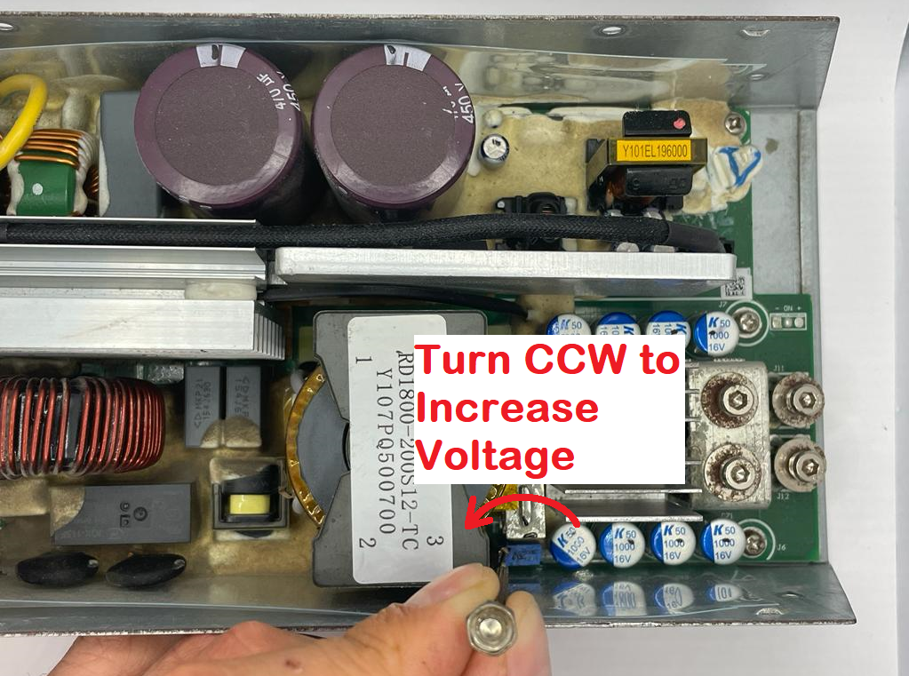

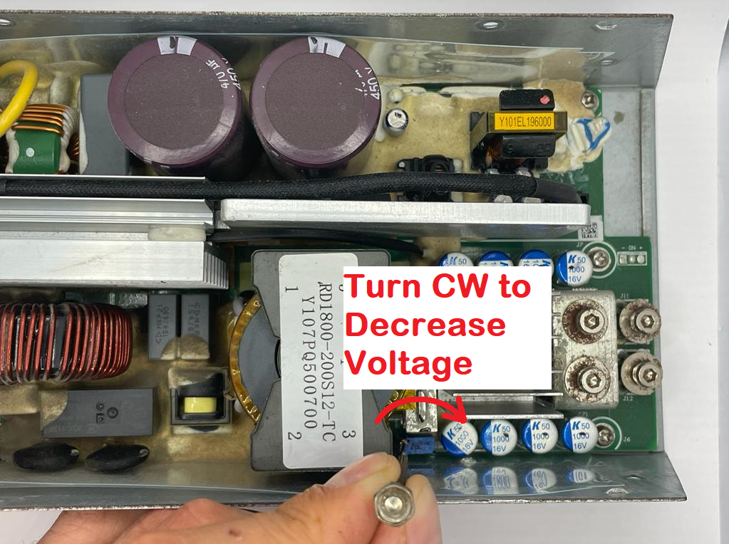

### 

### **Step 7**

Reinstall the top transparent plastic insulating shield. Be sure to orient it the same way it was before it was removed in step 3. The folded edges should face down, and the short straight side should be over the PSU fan. WARNING: Do not skip this step. The insulating shield must be installed. Failure to reinstall the insulating shield may result in some of the PSU components shorting to the outer case and damaging the PSU.

### **Step 8**

Reinstall the top PSU cover plate by aligning the top PSU cover plate’s six screw holes with the bottom enclosure’s six screw holes and installing the six screws. Do not overtighten the screws.

### **Step 9**

Power on the PSU by plugging it into a power outlet. Measure the output voltage with a digital multimeter being sure to have it set to the VDC setting. Repeat steps 1 through 9 until the desired voltage is reached.

# 

# Above 12.5V DC Modification Instructions

The instructions in this section are for modifying the output voltage of the APW3++ to be higher than 12.5V DC. This method is significantly more involved and should only be done if the output voltage must be above 12.5V DC. If the end goal is to modify the output voltage to be somewhere between 12V DC and 12.5V DC, see the “12-12.5V DC Modification Instructions” section above.

This method will require selecting a resistor value based on the desired output voltage. See the “Selecting Resistor Value” section below for more details.

## Recommended Tools and Parts for Modification

The following tools are recommended for modifying the APW3++ output voltage to be between 12-14.1V DC.

|  |  |  |
| --- | --- | --- |
| #1 Phillips Screwdriver | Soldering Iron and Solder  (70W or greater) | Digital Multimeter |
|  | | |
| 0603 Surface Mount Chip Resistor (Recommended) OR ¼W Axial Resistor  See “Selecting Resistor Value” section below to determine the correct resistor value | | |

## 

## Modification Steps

### **Step 1**

Unplug the power supply from the wall and ensure that the PSU fan stays on momentarily (5 to 45 seconds) after the PSU is unplugged and then turns off. The power supply discharges its high voltage capacitors through the PSU fan to help reduce the risk of electrical shock. WARNING: if the PSU fan has been removed or disconnected from the PSU, the capacitors will likely remain charged and present an elevated risk of electrical shock. Please read and adhere to all safety precautions given on page 1 of this document.

### 

### **Step 2**

With the PSU unplugged and the PSU fan no longer running, remove the top PSU cover plate by removing the 6 side screws (circled in red below) with a phillips screwdriver and pulling up on the top cover plate.

### 

 

### 

### **Step 3**

Make note of the orientation of the top transparent plastic insulating shield. Remove it by lifting up on its edge. Set aside.

### 

### **Step 4**

Remove the 5 PCB mounting screws (circled in read below).

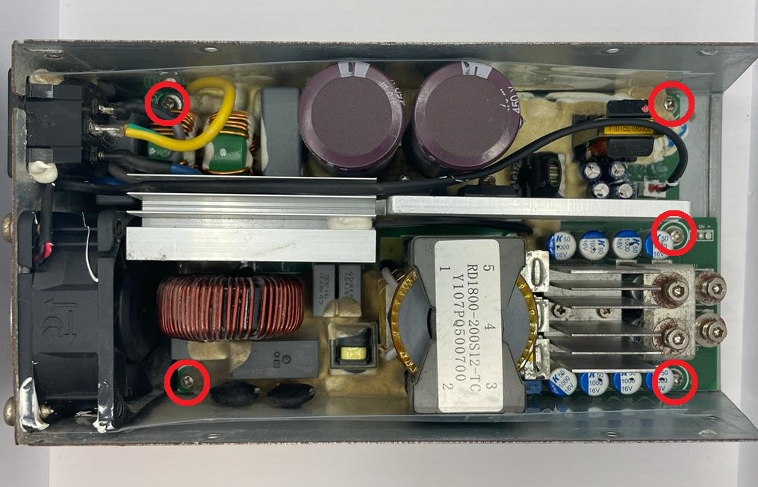

### **Step 5**

Disconnect the PSU fan by gently pulling up on the connector (circled in red below).

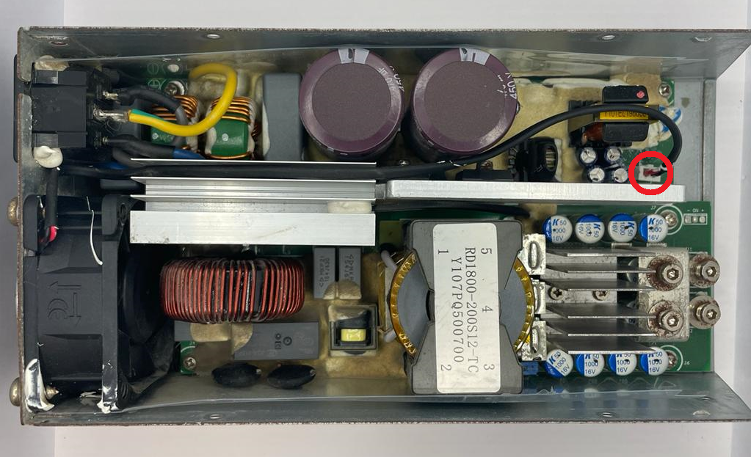

### **Step 6**

Remove the PSU fan and fan guard by removing the four fan mount screws on the back of the PSU and gently lifting up on the PSU fan.

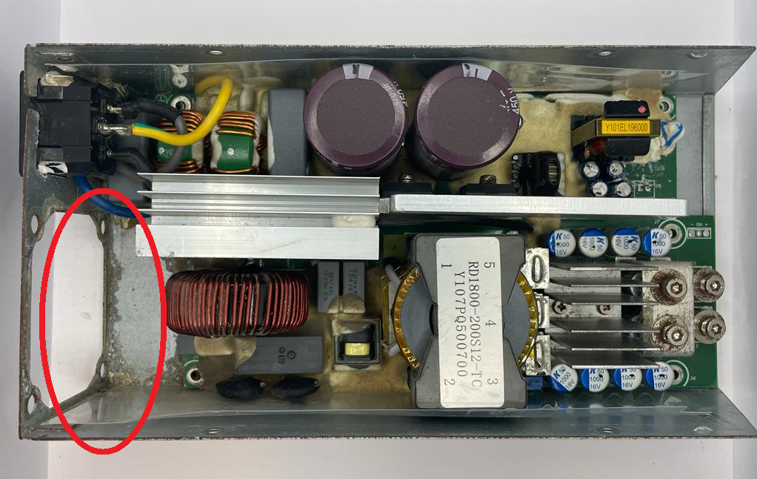

### 

### 

### **Step 7**

Remove the PCB from the PSU enclosure by gently lifting up and pulling out on the end opposite of where the PSU fan was. There will be some resistance due to small amounts of glue holding the PCB in place. Gently apply an upward pressure until the PCB is freed from the enclosure. The transparent bottom insulating shield should come out with the PCB.

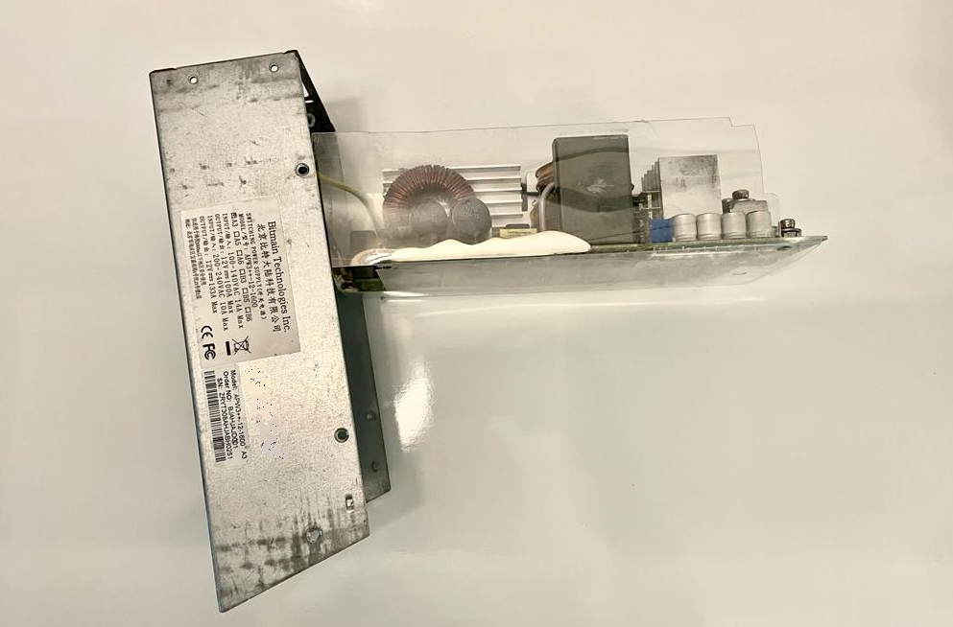

### 

### **Step 8**

Locate the potentiometer next to the large transformer. The potentiometer is a small blue box with a gold flathead screw. Remove it by gently prying it towards the edge of the PCB and then rocking it back and forth until it breaks off.



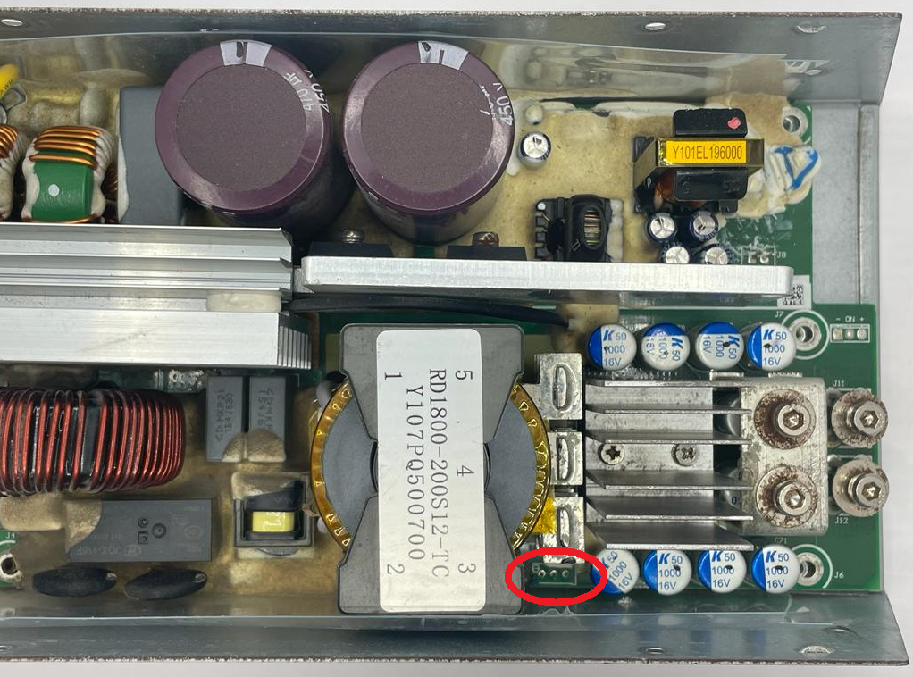

# 

### **Step 9**

Solder the resistor between the center and right pads of the potentiometer (outlined in red in the first picture below). The right pad is the pad closest to the large blue and silver capacitor. See “Selecting Resistor Value” section below to determine the correct resistor value. The second picture below shows the chip resistor installed (recommended). The third picture below shows the axial resistor installed.

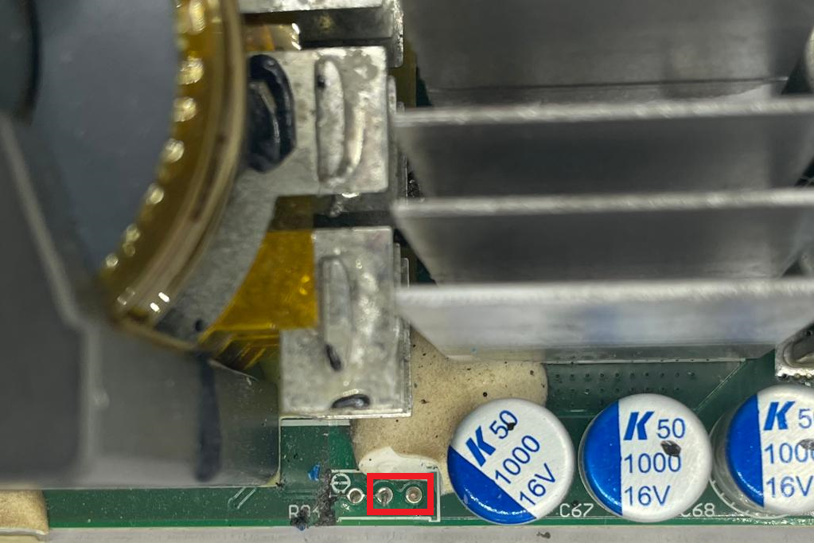

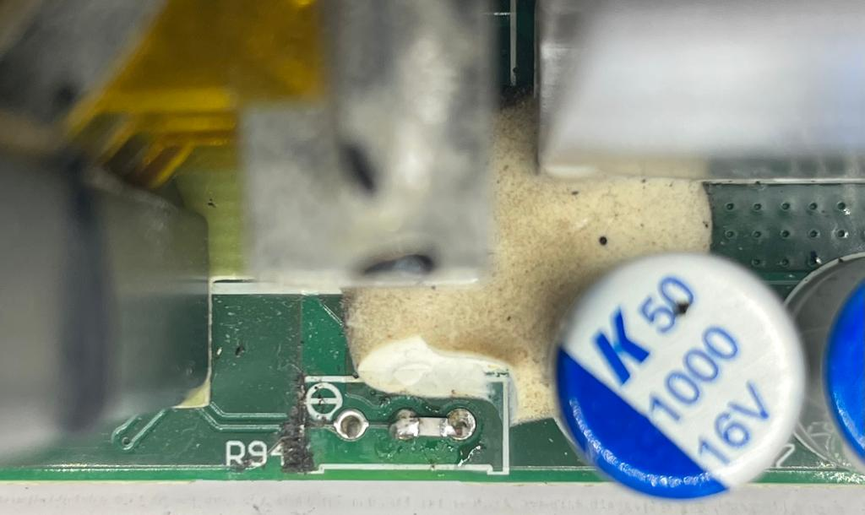 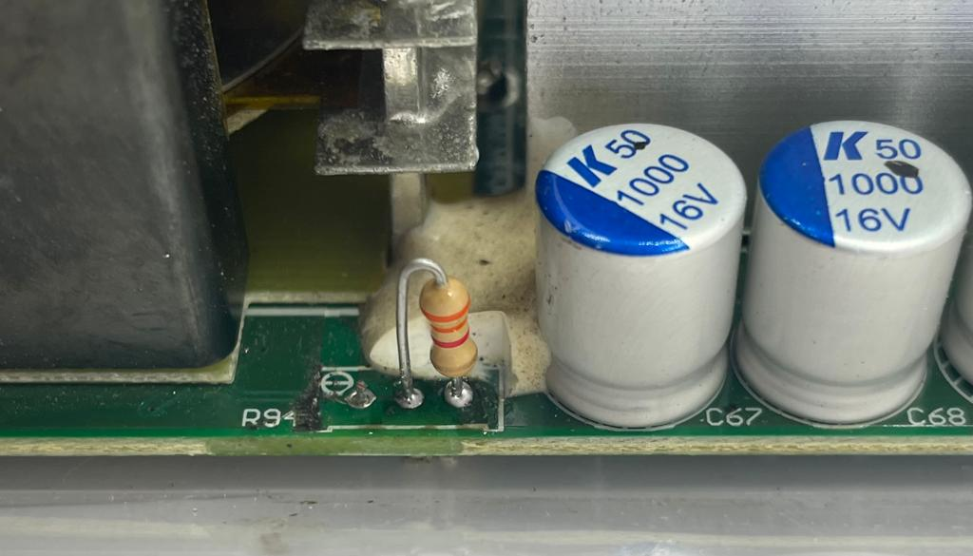

### **Step 10**

Remount the PCB to the PSU enclosure by sliding the PCB back into the enclosure, aligning the screw holes, and inserting the 5 mounting screws.

### **Step 11**

Reinstall the PSU fan by inserting the fan into its original position. Align the fan guard and insert the four fan mounting screws. Plug the fan back into the fan socket being sure to have the red wire on the side closer to the fan.

### **Step 12**

Reinstall the top transparent plastic insulating shield. Be sure to orient it the same way it was before it was removed in step 3. The folded edges should face down, and the short straight side should be over the PSU fan. WARNING: Do not skip this step. The insulating shield must be installed. Failure to reinstall the insulating shield may result in some of the PSU components shorting to the outer case and damaging the PSU.

### **Step 13**

Reinstall the top PSU cover plate by aligning the top PSU cover plate’s six screw holes with the bottom enclosure’s six screw holes and installing the six screws. Do not overtighten the screws.

### **Step 14**

Power on the PSU by plugging it into a power outlet. Measure the output voltage with a digital multimeter being sure to have it set to the VDC setting. Repeat steps 1 through 14 until the desired voltage is reached.

# 

# Selecting Resistor Value

The output voltage of the PSU can be adjusted by modifying the resistance between the two potentiometer pads shown above. In general, the higher the resistance the higher the voltage up to the max output of 14.1V. The graph below shows the general relationship between the PSU output voltage and the resistor value.

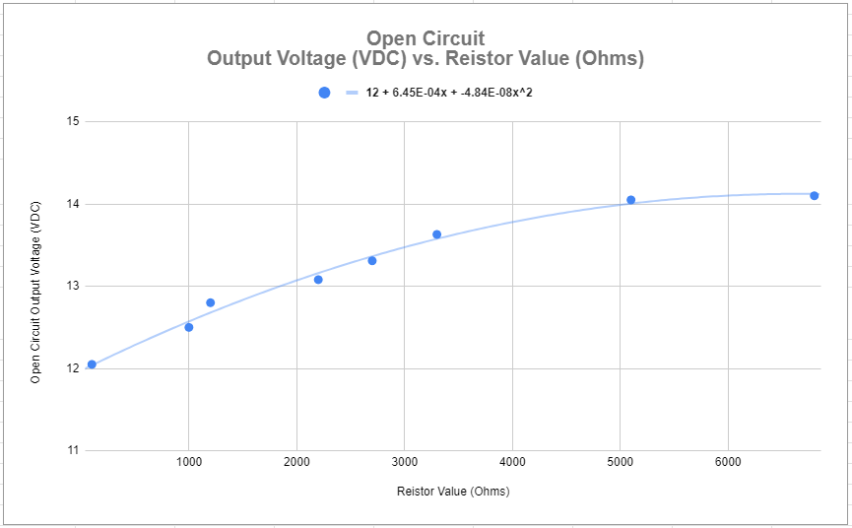

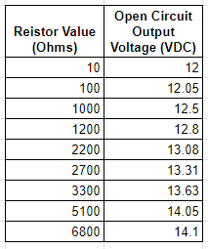

The table to the left can be used to identify the correct resistor value based on the desired output voltage.

If the desired output voltage isn’t shown in the table, the following equation can be used to approximate what the resistor value should be.

**Vout = 12 + 6.64E-4 * R - 4.84E-8 * R2**

Where Vout is the output voltage of the PSU and R is the resistor value in ohms.